April 23rd, 2006
Hi Gavin and Nadine
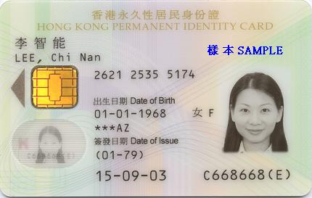
There won’t be much this week – only two brief diary entries. But I will try to spin it out a bit. To save me setting up a file for letters, I write over an earlier letter close to the date for the new letter. This one was from a letter on April 22nd 2001! Read it over before deleting the text. Interesting. I had written about a group of mainlanders here for a Wushu competition. The guys were real ‘heung ha lo’s’ and used the gym floor as an area for washing their clothes and the dry sauna to dry them!
On Thursday, I went over and collected your new ID card, Gavin. No problems and they do seem to be doing this very efficiently. I will probably give your ID card to Leonie when she returns to the US as she will probably see you before I do. The new ID cards certainly look quite attractive, too.
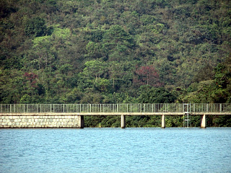
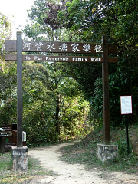
Yesterday, Leonie and I went for a ‘short’ run from Tai Tong to Tai Lam reservoir and then to the smaller Ho Pui reservoir before ending up at the Tunnel bus stop. Ho Pui is the reservoir where the guy with poor eyesight I wrote about a few months ago fell off a track and was found five days later. Run took 2 hr 13 min. But I didn't enjoy it much – it was hot (28⁰C), I was tired but most of all, the sunscreen lotion I had on my face was down running into my eyes and stinging them. I thought that because it was waterproof it would have stayed on my skin. Also, I was not wearing the headband you gave me, Gavin. This is probably the last run for the season unless it is cool next weekend.
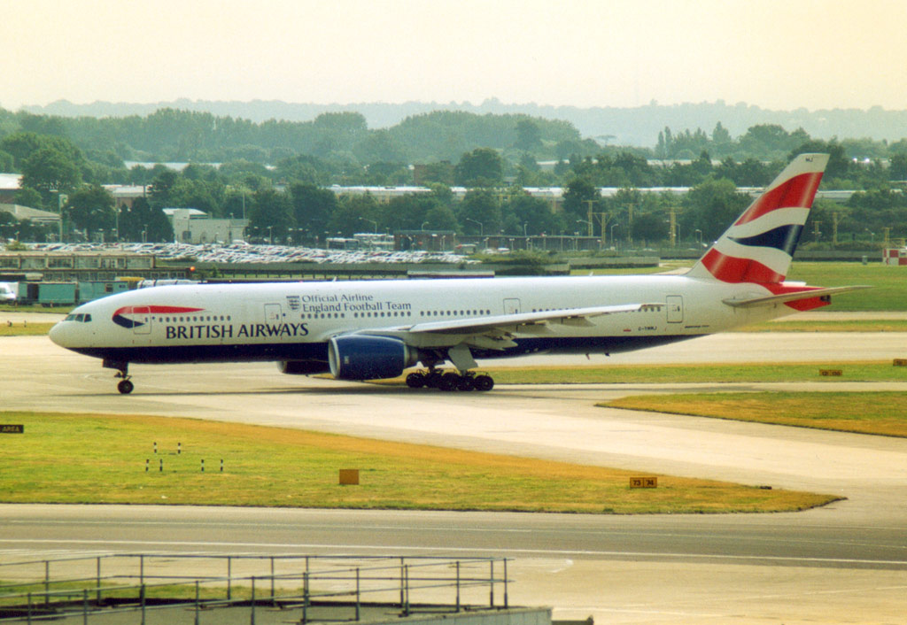
Gavin, you told me that you had a cheap ticket to come to HK. Saw an advertisement in the paper the other day that British Airways (BA) has introduced a special return ticket to the UK for just HK$3990. Also heard on the radio news that BA has slashed all its European flights by 50% to get back passengers it has lost to the low-cost ‘no frills’ airlines.
This coming Tuesday, the 25th is Anzac Day. I have included a few pictures related to the Gallipoli landings that I got from the Internet.
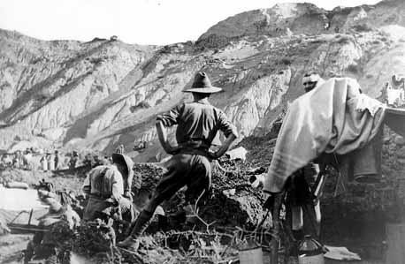
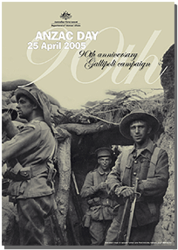
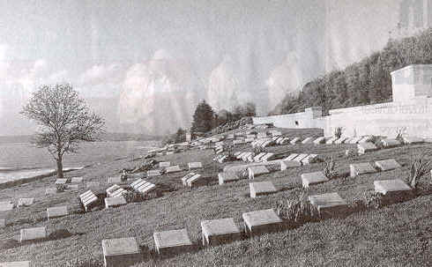
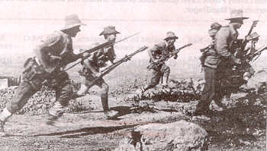
So, I did manage to spin it out a bit.

Cheers.

